**Supplementary data**

**Oral pH-triggered colon-specific ketoprofen loaded microspheres for the better management of early morning symptoms associated with rheumatoid arthritis. Part –II: Pharmacokinetic and pharmacodynamic assessment in rats**

Krishna Sankaa,b,*, Prabhakar Reddy Veerareddyc, and Rajeswara Rao Pragadad

*aDepartment of Pharmaceutics, School of Pharmacy & Technology Management, SVKM’S Narsee Monjee Institute of Management Studies (NMIMS) Deemed-to-be University, Shirpur, Maharashtra 425405, India.*

*bSchool of Pharmacy, Anurag University, Ghatkesar, Hyderabad, TS-500088, India.*

*cDepartmentof Pharmaceutics,University College of Pharmaceutical Sciences, Palamuru University, Mahbubnagar, TS 509001, India.*

*dDepartment of Pharmacology, University College of Pharmaceutical Sciences, Andhra University, Visakhapatnam 530003, AP, India.*

* **Corresponding Author:** Dr. Krishna Sanka, ORCID: <https://orcid.org/0009-0007-5074-9975>, Tel: +91-9701907755, E.Mail ID: [sreekrishna_ph2000@yahoo.co.in](mailto:sreekrishna_ph2000@yahoo.co.in)

**Table S1: Specificity data of ketoprofen**

|  |  |  |  |  |  |  |  |
| --- | --- | --- | --- | --- | --- | --- | --- |
| **S.NO** | **Sample ID** | **AREA** |  | **%Interference** | | **RT** |  |
|  |  | **KTP** | **PCM** | **KTP** | **PCM** | **KTP** | **PCM** |
| 1 | BL-1 | 1613 | 17543 | 2.69 | 1.28 | 5.4 | 6.5 |
| 2 | LLOQ | 59947 | 1360077 |  |  | 5.4 | 6.6 |
| 3 | BL-2 | 0 | 21601 | 0 | 2.48 | 0 | 6.5 |
| 4 | LLOQ | 42303 | 867726 |  |  | 5 | 6.2 |
| 5 | BL-3 | 0 | 18212 | 0 | 1.36 | 0 | 6.4 |
| 6 | LLOQ | 63797 | 1331636 |  |  | 5.4 | 6.5 |
| 7 | BL-4 | 0 | 15716 | 0 | 1.18 | 0 | 6.4 |
| 8 | LLOQ | 63825 | 1331704 |  |  | 5.3 | 6.6 |
| 9 | BL-5 | 0 | 15615 | 0 | 1.13 | 0 | 6.5 |
| 10 | LLOQ | 106092 | 1372668 |  |  | 5.4 | 6.5 |
| 11 | BL-6 | 0 | 13574 | 0 | 0.99 | 0 | 6.4 |
| 12 | LLOQ | 68372 | 1369923 |  |  | 5.4 | 6.6 |
| **“Acceptance Criteria:** Response of interfering peaks in STD BL at the retention time of analyte should be ≤ 20.00% of that in LLOQ. Response of interfering peaks in STD BL at the retention time of ISTD should be ≤ 5.00% of that in LLOQ”. | | | | | | | |

**Table S2: Calculated concentrations of sensitivity study for ketoprofen**

|  |  |  |
| --- | --- | --- |
| **LLOQ (0.625 µg/mL)** | | **Acceptance Criteria:** |
| **Replicate No.** | **Conc. (µg/mL)** | **“Acceptance criteria:** % Mean accuracy for LLOQ sample should be within 80.00-120.00%” |
| 1 | 0.659 |
| 2 | 0.687 |
| 3 | 0.694 |
| 4 | 0.690 |
| 5 | 0.658 |
| 6 | 0.635 |
| **Mean** | **0.670** |
| **SD** | **0.021** |
| **%CV** | **3.17** |
| **%Mean Accuracy** | **107.23** |

**Table S3: Calculated concentrations of QC samples for the matrix effect of ketoprofen**

|  |  |  |  |
| --- | --- | --- | --- |
| **S. No.** | **QC** | **HQC** | **LQC** |
| **Nominal Concentration (µg/mL)** | 32.00 | 2.30 |
| 27.2-36.8 | 1.955-2.645 |
| **Plasma Sample No.** | **Calculated Concentration (μg/mL)** | **Calculated Concentration (μg/mL)** |
| 1 | P-1 | 34.31 | 2.54 |
| 2 | 34.61 | 2.38 |
| 3 | 36.02 | 2.21 |
| 4 | P-2 | 35.53 | 2.01 |
| 5 | 36.22 | 2.08 |
| 6 | 35.43 | 2.04 |
| 7 | P-3 | 35.60 | 2.18 |
| 8 | 35.21 | 2.05 |
| 9 | 35.29 | 2.04 |
| 10 | P-4 | 34.77 | 2.02 |
| 11 | 34.28 | 2.03 |
| 12 | 34.19 | 2.01 |
| 13 | P-5 | 34.41 | 1.98 |
| 14 | 34.56 | 2.00 |
| 15 | 34.59 | 1.98 |
| 16 | P-6 | 34.06 | 2.03 |
| 17 | 33.94 | 2.03 |
| 18 | 34.35 | 2.06 |
| **Mean** | | **34.85** | **2.09** |
| **SD** | | **0.69** | **0.15** |
| **%CV** | | **1.98** | **7.14** |
| **%Mean Accuracy** | | **108.92** | **90.97** |
| **“Acceptance Criteria:** The %mean accuracy of LQC and HQC samples prepared from different biological matrix lots should be within 85.00-115.00%. The %CV of LQC and HQC samples prepared from different lots should ≤ 15.00%” | | | |

**Table S4: Intra-inter-day precision and accuracy data for ketoprofen**

|  |  |  |  |  |  |  |  |
| --- | --- | --- | --- | --- | --- | --- | --- |
| **DAY I** | **P&A I** | | | **DAY II** | **P&A IIA** | | |
| **HQC** | **MQC** | **LQC** | **HQC** | **MQC** | **LQC** |
| **M** | 30.79 | 22.62 | 2.30 | M | 30.92 | 23.22 | 2.36 |
| **SD** | 0.40 | 0.87 | 0.19 | SD | 0.75 | 0.79 | 0.13 |
| **%CV** | 1.30 | 3.85 | 8.33 | %CV | 2.41 | 3.41 | 5.50 |
| **%MA** | 96.23 | 107.69 | 100.07 | %MA | 96.61 | 110.57 | 102.43 |
| **N** | 6 | 6 | 6 | N | 6 | 6 | 6 |
| **DAY II** | **P&A II**B | | | **DAY II** | **P&A II**C | | |
| **HQC** | **MQC** | **LQC** | **HQC** | **MQC** | **LQC** |
| **M** | 32.08 | 19.49 | 2.61 | M | 29.50 | 21.27 | 2.290 |
| **SD** | 0.25 | 0.68 | 0.10 | SD | 0.82 | 1.27 | 0.069 |
| **%CV** | 0.77 | 3.48 | 3.94 | %CV | 2.78 | 5.99 | 3.000 |
| **%MA** | 100.26 | 92.83 | 113.39 | %MA | 92.18 | 101.30 | 99.554 |
| **N** | 6 | 6 | 6 | N | 6 | 6 | 6 |
| **DAY III** | **P&A III** | | |  | **Between batch P&A** | | |
| **HQC** | **MQC** | **LQC** | **HQC** | **MQC** | **LQC** |
| **M** | 31.40 | 21.12 | 2.27 | **M** | 30.94 | 21.54 | 2.37 |
| **SD** | 0.94 | 0.84 | 0.14 | **SD** | 0.63 | 0.89 | 0.13 |
| **%CV** | 3.01 | 3.96 | 6.02 | **%CV** | 2.05 | 4.14 | 5.36 |
| **%MA** | 98.12 | 100.58 | 98.77 | **%MA** | 96.68 | 102.59 | 102.84 |
| **N** | 6 | 6 | 6 | N | 30 | 30 | 30 |
| **“Acceptance criteria:** The %accuracy for all CC standards should be within 85.00-115.00%. At least 75% of CC standards should meet the acceptance criteria. The regression (r2 value) should be ≥ 0.98.” | | | | | | | |

**Table S5. Recovery study data of ketoprofen**

|  |  |  |  |  |  |  |
| --- | --- | --- | --- | --- | --- | --- |
| **Replicate No.** | **HQC** | | **MQC** | | **LQC** | |
| **Aqueous Area Ratio** | **Extracted Area Ratio** | **Aqueous Area Ratio** | **Extracted Area Ratio** | **Aqueous Area Ratio** | **Extracted Area Ratio** |
| 1 | 2.23 | 1.97 | 1.59 | 1.31 | 0.18 | 0.15 |
| 2 | 2.18 | 1.99 | 1.54 | 1.31 | 0.21 | 0.19 |
| 3 | 2.21 | 2.18 | 1.56 | 1.29 | 0.21 | 0.16 |
| Mean | 2.21 | 2.04 | 1.57 | 1.31 | 0.20 | 0.17 |
| SD | 0.02 | 0.12 | 0.03 | 0.01 | 0.01 | 0.02 |
| % CV | 1.07 | 5.83 | 1.66 | 0.79 | 6.82 | 12.04 |
| % MR | 92.62 | | 83.38 | | 83.32 | |
| Overall %MR | 84.44 | | | | | |
| Overall SD | 5.35 | | | | | |
| Overall %CV | 6.19 | | | | | |
| **“Acceptance Criteria:** The %CV of recovery at each QC level and for ISTD should be ≤ 15.00%. The overall mean recovery %CV for all QC levels should be ≤ 20.00%”. | | | | | | |

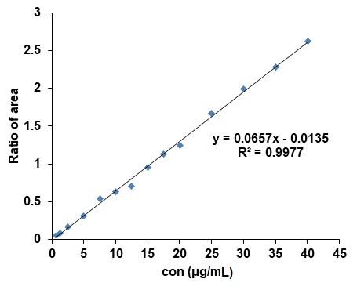

Fig S1. Standard linear plot of ketoprofen

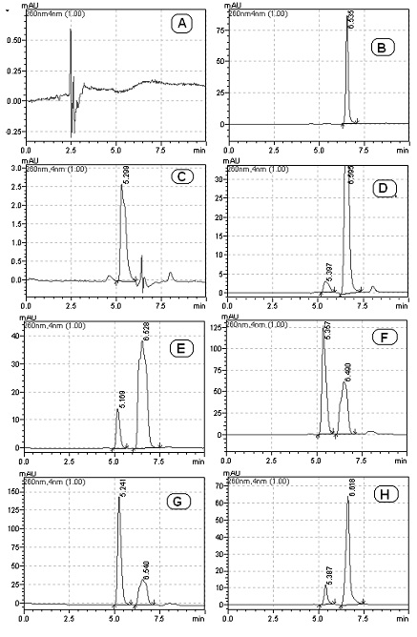

Fig S2. Chromatograms of blank plasma (A), blank plasma with IS (B), Blank plasma with analyte (C), LLOQ (D), LQC (E), MQC (F), HQC (G), plasma after oral administration of ketoprofen (H)