**Supplementary data**

**Study on the factors affecting the competitiveness of biopharmaceutical industry cluster: Evidence from Guangdong and Zhejiang of China**

Qiu Zhanga, b,*, Mandong Huanga, Xiaoxin Huanga, Lu Ganc, Yiling Lid, Huiying Huanga

aSchool of Pharmaceutical Business, Guangdong Pharmaceutical University, Guangzhou, 510006, China

bGuangdong Health Economics and Health Promotion Research Center, Guangzhou, 510006, China

cBusiness School, University of Leeds, Leeds, LS2 9JT, UK

dSchool of Chemistry and Chemical Engineering, Guangdong Pharmaceutical University, Guangzhou, 510006, China

* Corresponding author. School of Pharmaceutical Business, Guangdong Pharmaceutical University, Guangzhou, 510006, China.

E-mail address:[zhangqiu@gdpu.edu.cn](mailto:zhangqiu@gdpu.edu.cn(Zhang) (Q. Zhang).

**Appendices**

**Appendices A：Supplementary Figures**

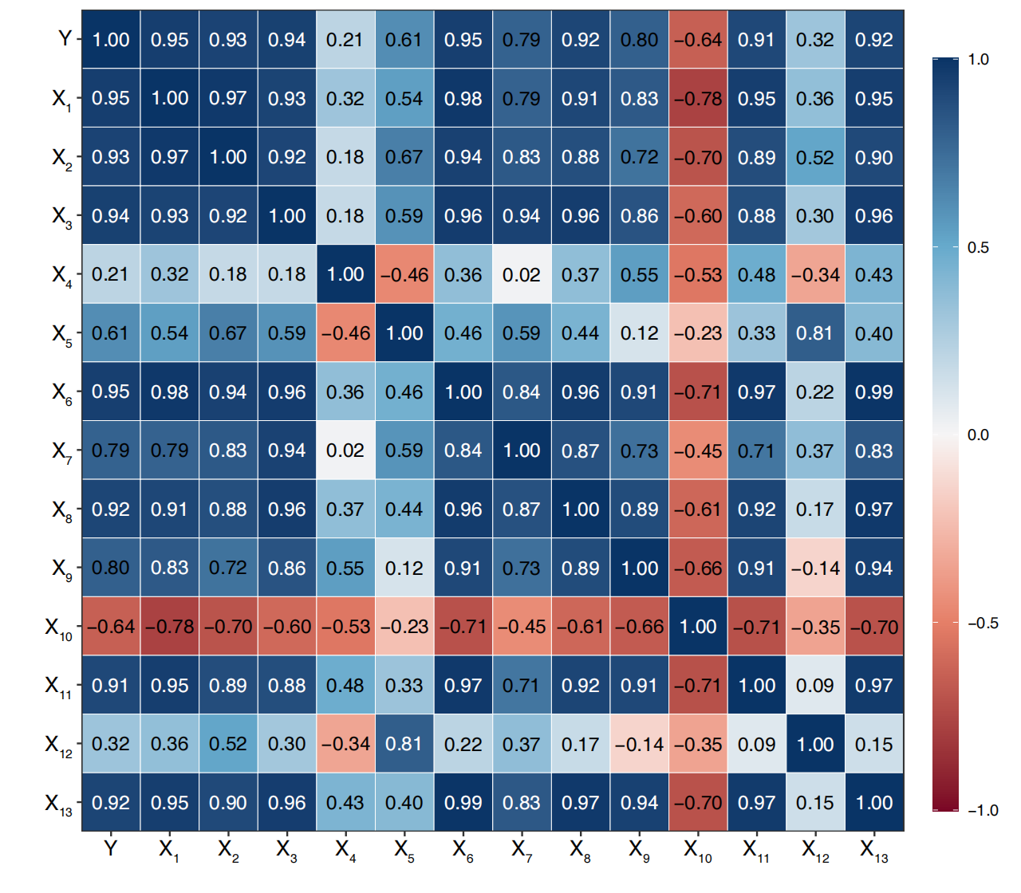

**Figure A.1**

Correlation Matrix of Guangdong.

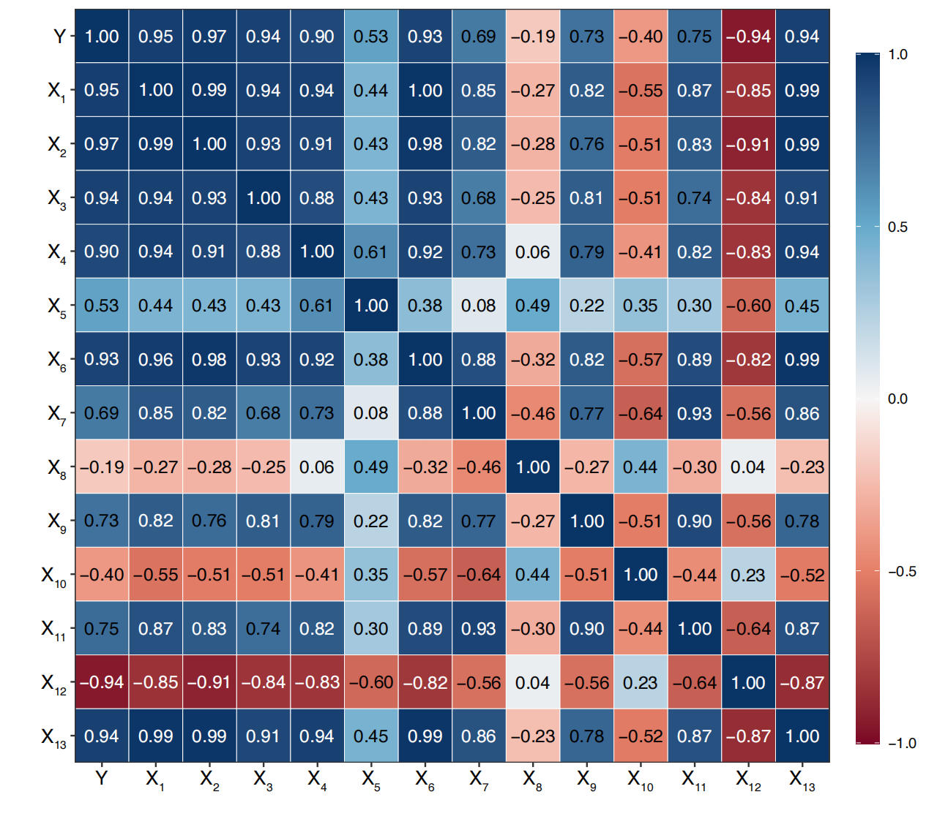**Figure A.2**

Correlation Matrix of Zhejiang.

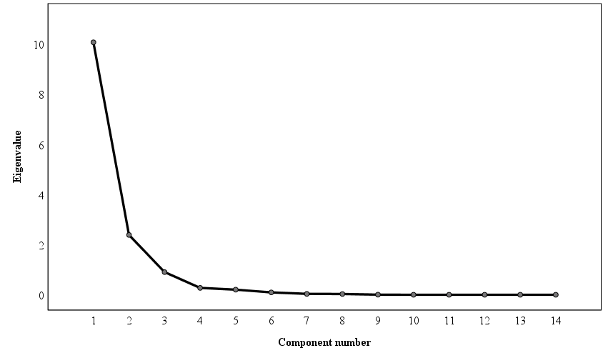

Figure A.3

Scatter plot of Guangdong.

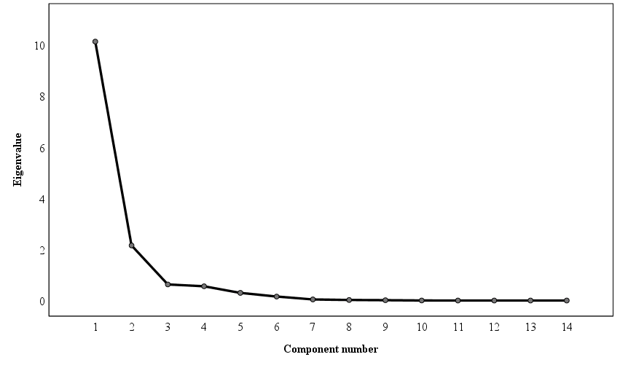

**Figure A.4**

Scatter plot of Zhejiang.

Appendices B：Supplementary Tables

Table B.1

Total Variance Explained in Guangdong.

|  |  |  |  |  |  |  |
| --- | --- | --- | --- | --- | --- | --- |
| **Components** | **Initial eigenvalue** | | | **The squared sum of extracted loads** | | |
| **Total** | **VP****1** | **CCR****2（%）** | **Total** | **VP1** | **CCR2（%）** |
| 1 | 10.07 | 71.91 | 71.91 | 10.07 | 71.91 | 71.91 |
| 2 | 2.39 | 17.04 | 88.95 | 2.39 | 17.04 | 88.95 |
| 3 | 0.90 | 6.46 | 95.41 |  |  |  |
| 4 | 0.27 | 1.96 | 97.37 |  |  |  |
| 5 | 0.20 | 1.45 | 98.82 |  |  |  |
| ︙ | ︙ | ︙ | ︙ |  |  |  |
| 14 | 0.00 | 0.00 | 100.00 |  |  |  |

1 VP: Variance Percentage; 2 CCR: Cumulative Contribution Rate.

Table B.2

Total Variance Explained in Zhejiang.

|  |  |  |  |  |  |  |
| --- | --- | --- | --- | --- | --- | --- |
| **Components** | **Initial eigenvalue** | | | **The squared sum of extracted loads** | | |
| **Total** | **VP1** | **CCR2（%）** | **Total** | **VP1** | **CCR2（%）** |
| 1 | 10.13 | 72.34 | 72.34 | 10.13 | 72.34 | 72.34 |
| 2 | 2.15 | 15.38 | 87.72 | 2.15 | 15.38 | 87.72 |
| 3 | 0.63 | 4.50 | 92.22 |  |  |  |
| 4 | 0.56 | 3.98 | 96.20 |  |  |  |
| 5 | 0.30 | 2.14 | 98.33 |  |  |  |
| ︙ | ︙ | ︙ | ︙ |  |  |  |
| 14 | 0.00 | 0.00 | 100.00 |  |  |  |

1 VP: Variance Percentage; 2 CCR: Cumulative Contribution Rate.