**Liujunzi decoction** **attenuates cisplatin-induced anorexia in rats via inhibiting hepatic and ileal PERK/eIF2α/ATF4/CHOP pathway-mediated GDF15/GFRAL expression**

Yongzhao Dai, Wanting Hu, Jinyuan Han, Yaozhong Zhao, Xipei Wu, Xiuxiu Liao, Ke Nie*

*School of Chinese Materia Medica, Guangdong Pharmaceutical University, Guangzhou 510006, P.R. China*

*Corresponding author: Ke Nie, School of Chinese Materia Medica, Guangdong Pharmaceutical University, 280 Waihuandong Road Guangzhou Higher Education Mega Center, Guangzhou, 510006, China. Email address: [nicknk@hotmail.com](mailto:nicknk@hotmail.com)

Supplementary Table S1. Ginsenoside Rg1 gradient analysis method.

|  |  |  |
| --- | --- | --- |
| t（min) | A（%), acetonitrile | B（%),Water |
| 0-35 | 19 | 81 |
| 35-55 | 19-29 | 81-71 |
| 55-70 | 29 | 71 |
| 70-100 | 29-40 | 71-60 |

Supplementary Table S2. Atractylenolide III gradient analysis method.

|  |  |  |
| --- | --- | --- |
| T (min) | A (%), Acetonitrile | B (%), Water |
| 0-16 | 60-76 | 40-24 |
| 16-18 | 76-100 | 24-0 |
| 18-30 | 100 | 0 |

Supplementary Table S3. Pachymic acid gradient analysis method.

|  |  |  |
| --- | --- | --- |
| T (min) | A (%), Methanol | B (%), Water |
| 0-10 | 80-88 | 20-12 |
| 10-25 | 88-94 | 12-6 |
| 25-30 | 94-100 | 6-0 |

Supplementary Table S4. Succinic acid analysis method.

|  |  |  |
| --- | --- | --- |
| T (min) | A (%), Methanol | B (%), KH2PO4 |
| 0-20 | 7 | 93 |

Supplementary Table S5. Liquiritin gradient analysis method.

|  |  |  |
| --- | --- | --- |
| T (min) | A (%), Acetonitrile | B (%), 0.05% H3PO4 |
| 0-8 | 19 | 81 |
| 8-35 | 19-50 | 81-50 |
| 35-36 | 50-100 | 50-0 |
| 36-40 | 100-19 | 0-81 |

Supplementary Table S6. Hesperidin gradient analysis method.

|  |  |  |
| --- | --- | --- |
| T (min) | A (%), Acetonitrile | B (%), Water |
| 0-10 | 22 | 78 |
| 10-20 | 22-48 | 78-52 |
| 20-35 | 48 | 52 |

Supplementary Table S7. 6-gingerol gradient analysis method.

|  |  |  |
| --- | --- | --- |
| T (min) | A (%), Acetonitrile | B (%), 0.1% formic acid |
| 0-10 | 45 | 55 |
| 10-15 | 45-48 | 55-52 |
| 15-17 | 48-60 | 52-40 |
| 17-43 | 60 | 40 |
| 43-45 | 60-67 | 40-33 |
| 45-48 | 67-69 | 33-31 |
| 48-58 | 69-71 | 31-29 |

Supplementary Table S8. Jujuboside A gradient analysis method.

|  |  |  |
| --- | --- | --- |
| T (min) | A (%),0.01% phosphoric acid aqueous solution | B (%), Acetonitrile |
| 0.01-15 | 80 | 20 |
| 15-30 | 80-65 | 20-35 |
| 30-35 | 65-55 | 35-45 |
| 35-40 | 55-20 | 45-80 |
| 40-60 | 20-80 | 80-20 |

Supplementary Table S9. Retention time, peak area, and concentration of standards

|  |  |  |  |
| --- | --- | --- | --- |
| Standards | Retention time (min) | Peak area (mAU) | Concentration (mg/mL) |
| Ginsenoside Rg1 | 3.522 | 1155444 | 0.216 |
| Atractylenolide III | 3.033 | 8630515 | 0.322 |
| Pachymic acid | 9.000 | 657783 | 0.994 |
| Succinic acid | 2.369 | 926308 | 1.03 |
| Liquiritin | 4.014 | 3830 | 0.0194 |
| Hesperidin | 2.568 | 2819033 | 0.204 |
| 6-gingerol | 7.642 | 2108165 | 0.51 |
| Jujuboside A | 8.512 | 955427 | 0.0532 |

Supplementary Table S10. Retention time, peak area, and concentration of ingredients in single herbs and LJZD lyophilized powder

|  |  |  |  |  |
| --- | --- | --- | --- | --- |
| Analytes | | Retention time (min) | Peak area (mAU) | Concentration (mg/g) |
| Ginsenoside Rg1 | single herb | 3.593 | 2137039 | 3.665 |
| LJZD lyophilized powder | 4.062 | 14713723 | 13.721 |
| Atractylenolide III | single herb | 3.032 | 335287 | 0.060 |
| LJZD lyophilized powder | 2.903 | 4408164 | 0.808 |
| Pachymic acid | single herb | 9.098 | 17022812 | 119.790 |
| LJZD lyophilized powder | 8.889 | 16983029 | 117.202 |
| Succinic acid | single herb | 2.324 | 258815 | 0.236 |
| LJZD lyophilized powder | 2.333 | 3479317 | 3.835 |
| Liquiritin | single herb | 4.087 | 334069 | 84.608 |
| LJZD lyophilized powder | 4.090 | 363451 | 9.076 |
| Hesperidin | single herb | 2.551 | 13193707 | 144.986 |
| LJZD lyophilized powder | 2.584 | 10693260 | 14.881 |
| 6-gingerol | single herb | 7.685 | 2448837 | 26.928 |
| LJZD lyophilized powder | 7.816 | 557012 | 3.324 |
| Jujuboside A | single herb | 8.591 | 9810 | 0.001 |
| LJZD lyophilized powder | 8.889 | 586156 | 0.164 |

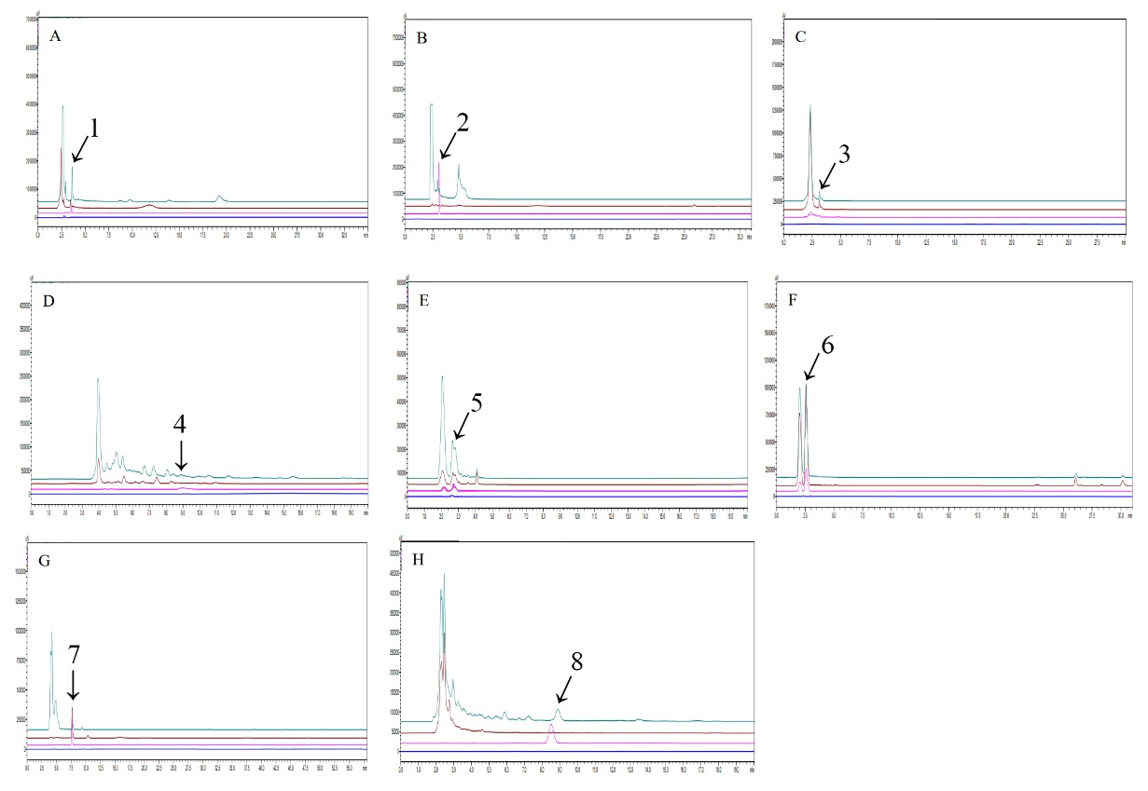

Supplementary Fig. S1. HPLC analyses of representative ingredients in LJZD lyophilized powder. Standards present in pink, single herbs in brown, LJZD lyophilized powder in green, and solution in bule. The analytes are ginsenoside Rg1 (A, peak 1, 4.062 min), atractylenolide III (B, peak 2, 2.903 min), pachymic acid (C, peak 3, 8.889 min), succinic acid (D, peak 4, 2.333 min), liquiritin (E, peak 5, 4.090 min), hesperidin (F, peak 6, 2.584 min), 6-gingerol (G, peak 7, 7.816 min), and jujuboside A (H, peak 8, 8.889 min).