**Supplementary Information**

**Optimization study on the flavonoid extraction process from *Abrus precatorius* leaves and the comparison of total flavonoid content by HPLC and UV**

YUAN Xujiang1 **\***, HE Cuimin1 , Xue xianmei1 , LIANG Zhike1 , CHEN Yanfen2

1*Center for New Drug Research and Development / Guangdong Provincial Key Laboratory of New Drug Dosage Form / Key Laboratory of Modern Chinese Medicine,Department of Education of Guangdong Province / Traditional Chinese Medicine Preparation Laboratory, National Administration of Traditional Chinese Medicine (LevelⅢ), Guangdong Pharmaceutical University, Guangzhou, 510006, China*

2 *School of Traditional Chinese Medicine, Guangdong Pharmaceutical University, Guangzhou, 510006, China*

[\***Corresponding author**] E-mail: xjyuan.xj@163.com.

Contents

**Table S1** Collection information and total flavonoid content of 14 batches of APL 3

**Table S2** The content data of flavonoids of APL by single factor parametric variables (mg/g) 4

**Fig.S1** TLC detection of flavonoids at different ethanol eluting fractions (λ365 nm, AlCl3). 5

**Fig.S2** UV spectroscopy detection of flavonoids at different ethanol eluting fractions 6

**Table S1** Collection information and total flavonoid content of 14 batches of APL

|  |  |  |  |  |  |
| --- | --- | --- | --- | --- | --- |
| **NO.** | **Batch number** | **Origin** | **Collection time** | **HPLC/Total flavonoids** | **UV/Total flavonoids** |
| S1 | XSY-20190501 | Pingxiang County, Chongzuo City, Guangxi | 2019.05 | 89.30±0.39 | 40.11±1.54 |
| S2 | XSY-20190502 | Nanning, Guangxi | 2019.05 | 77.10±3.16 | 30.39±1.59 |
| S3 | XSY-20190601 | Zhanjiang, Guangdong | 2019.06 | 84.29±2.94 | 33.83±1.21 |
| S4 | XSY-20190602 | Yulin, Guangxi | 2019.06 | 88.31±3.90 | 33.59±0.59 |
| S5 | XSY-20190603 | Yulin, Guangxi | 2019.06 | 70.15±1.98 | 33.15±0.56 |
| S6 | XSY-20190604 | Heyuan, Guangdong | 2019.06 | 93.24±2.90 | 37.96±2.53 |
| S7 | XSY-20190605 | Meizhou, Guangdong | 2019.06 | 75.41±3.22 | 31.43±2.69 |
| S8 | XSY-20190606 | Guangzhou, Guangdong | 2019.06 | 91.11±5.41 | 44.29±1.35 |
| S9 | XSY-20190607 | Vietnam | 2019.06 | 110.25±0.87 | 47.88±1.47 |
| S10 | XSY-20191001 | Baise, Guangxi | 2019.10 | 93.29±2.34 | 45.04±1.60 |
| S11 | XSY-20191002 | Lingshan County, Qinzhou City, Guangxi | 2019.10 | 90.78±2.07 | 38.45±1.72 |
| S12 | XSY-20200601 | Baise, Guangxi | 2020.06 | 89.98±4.44 | 36.27±1.18 |
| S13 | XSZ-20200602 | Yulin, Guangxi | 2020.06 | 101.12±4.75 | 42.38±1.48 |
| S14 | XSZ-20200701 | Luchuan County, Yulin City, Guangxi | 2020.07 | 99.52±2.23 | 41.96±1.68 |

**Table S2** The content data of flavonoids of APL by single factor parametric variables (mg/g)

|  |  |  |  |  |  |  |  |  |
| --- | --- | --- | --- | --- | --- | --- | --- | --- |
| **Fingle factor** | **HPLC** | | | | | | | **UV**  **Total flavonoids** |
| Ethanol concentration | **1** | **2** | **3** | **4** | **5** | **6** | **7** |
| 30% | 8.395 | 8.100 | 6.512 | 11.299 | 17.371 | 2.982 | 6.659 | 30.28 |
| 40% | 7.374 | 7.099 | 5.635 | 10.116 | 15.769 | 2.739 | 5.931 | 29.33 |
| 50% | 8.506 | 8.155 | 6.342 | 11.943 | 18.640 | 3.390 | 7.005 | 33.02 |
| 60% | 8.911 | 8.504 | 6.302 | 12.468 | 19.249 | 3.399 | 6.810 | 34.43 |
| 70% | 9.243 | 8.769 | 5.303 | 12.637 | 19.199 | 3.600 | 6.685 | 33.87 |
| Solid-liquid ratio | **1** | **2** | **3** | **4** | **5** | **6** | **7** | UV |
| 1:20 | 7.432 | 7.115 | 4.743 | 10.524 | 15.299 | 2.682 | 5.351 | 27.69 |
| 1:30 | 8.462 | 8.164 | 5.509 | 11.750 | 17.375 | 2.753 | 5.808 | 29.87 |
| 1:40 | 9.388 | 8.937 | 5.605 | 12.837 | 18.361 | 3.075 | 6.279 | 32.96 |
| 1:50 | 9.605 | 9.238 | 5.833 | 12.600 | 18.446 | 2.582 | 5.495 | 31.95 |
| 1:60 | 10.006 | 9.514 | 6.076 | 13.691 | 20.006 | 3.164 | 6.562 | 35.26 |
| Time (h) | **1** | **2** | **3** | **4** | **5** | **6** | **7** | UV |
| 0.5 | 8.080 | 7.640 | 4.833 | 10.830 | 16.766 | 2.953 | 5.816 | 29.79 |
| 1 | 7.901 | 7.476 | 5.509 | 11.423 | 19.487 | 2.951 | 6.065 | 33.70 |
| 1.5 | 9.040 | 8.593 | 6.517 | 13.007 | 19.053 | 2.997 | 6.348 | 34.08 |
| 2 | 7.690 | 7.373 | 6.500 | 11.602 | 17.688 | 3.108 | 6.367 | 32.24 |
| Times | **1** | **2** | **3** | **4** | **5** | **6** | **7** | **UV** |
| 1 | 8.398 | 8.009 | 5.881 | 12.048 | 18.299 | 3.737 | 7.841 | 34.39 |
| 2 | 8.878 | 8.574 | 7.348 | 13.558 | 21.647 | 3.563 | 7.748 | 37.86 |
| 3 | 8.137 | 7.935 | 8.416 | 13.280 | 22.093 | 3.351 | 7.442 | 38.06 |

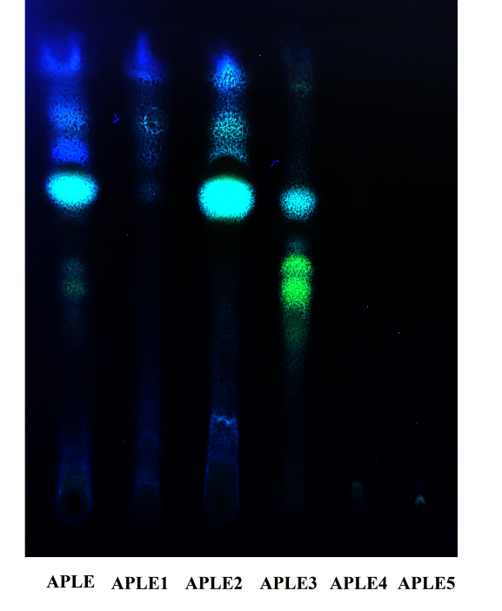

**Fig.S1** TLC detection of flavonoids at different ethanol eluting fractions (λ365 nm, AlCl3).

Total extract(APLE), Water eluent (APLE1), 30% alcohol eluent (APLE2), 50% alcohol eluent (APLE3), 80% alcohol eluent (APLE4), 95% alcohol eluent (APLE5).

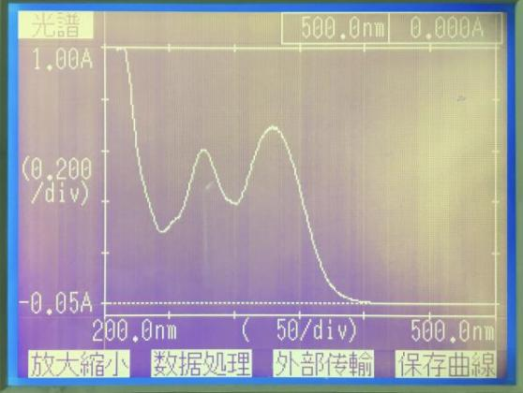 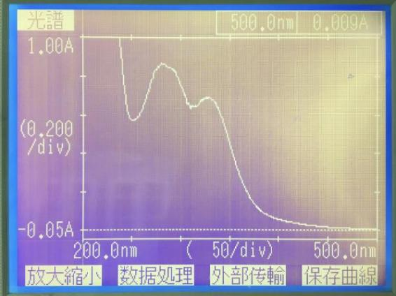

Cirsimarin **APLE(**Total extract)

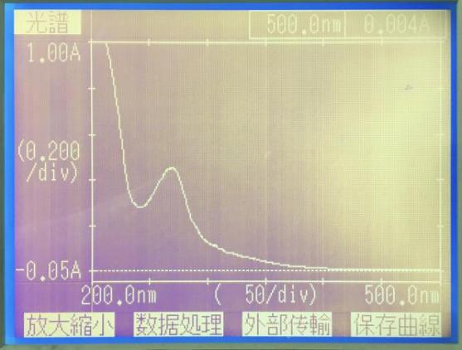 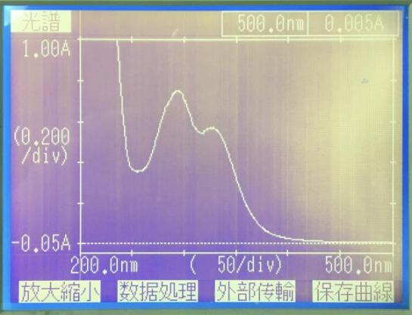

**APLE1(**Water eluent) **APLE2(**30% alcohol eluent)

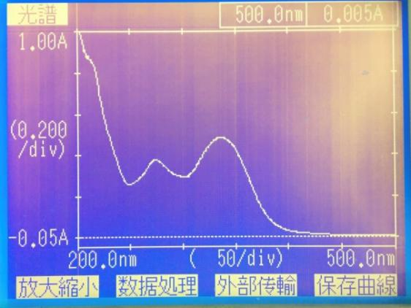 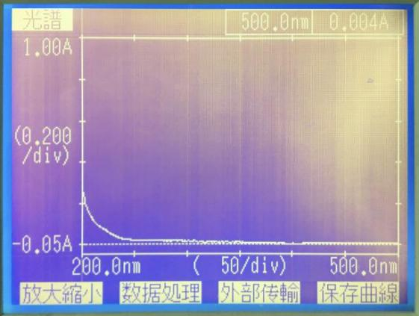

**APLE3(**50% alcohol eluent**) APLE4 (**80% alcohol eluent**)**

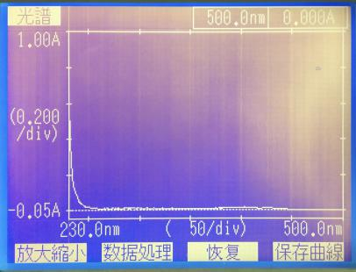

**APLE5 (**95% alcohol eluent**)**

**Fig.S2** UV spectroscopy detection of flavonoids at different ethanol eluting fractions